YEAR 11 ATAR HUMAN BIOLOGY

DO NOT MARK THIS BOOKLET

Multiple Choice 25 Marks

Short Answer 30 Marks

Total 55 Marks

Task 5: Circulatory and Respiratory Systems

Part 1: Multiple Choice (25 marks)

Please circle the correct answer on the multiple choice answer sheet provided

1. Wind pipe is a common name for:

a) Larynx

b) Pharynx

c) Trachea

d) Diaphragm

1. During expiration the:

a) diaphragm lowers

b) ribs move upwards and outwards

c) size of the thoracic cavity increases

d) pressure inside the thoracic cavity increases

1. Which does NOT help to maintain the concentration gradients between the alveoli and the capillaries?

a) oxygen combining with haemoglobin on the red blood cells

b) the beating of the heart to maintain blood flow

c) breathing in and out

d) accumulation of carbon dioxide in the alveoli

1. Carbon dioxide is carried in the blood mainly in the:

a) lymph

b) red blood cells

c) white blood cells

d) plasma

1. One function of platelets is to

a) assist in the clotting of blood

b) carry haemoglobin

c) engulf bacteria

d) transport carbon dioxide

1. The valves between the chambers of the heart ensures:

a) blood is maintained at a constant pressure

b) blood is pumped at all times

c) blood flows in one direction

d) all chambers of the heart can fill with blood simultaneously

1. During the cardiac cycle the following events take place:

atrial systole

diastole

ventricular systole

In which order do the events occur?

a) atrial systole, diastole, ventricular systole

b) diastole, ventricular systole, diastole, atrial systole

c) ventricular systole, atrial systole, diastole

d) atrial systole, ventricular systole, diastole

1. In which vessel would you expect blood pressure to be the highest?

a) superior vena cava

b) capillary

c) aorta

d) pulmonary vein

1. The lymphatic system performs the following functions EXCEPT the:

a) transport of glucose

b) return of fluid to the blood

c) trapping of foreign particles in the lymph

d) immune response by white blood cells

1. Which of the following are involved in pulmonary circulation?
2. Right ventricle, pulmonary trunk, left atrium
3. Superior vena cava, right atrium, right ventricle
4. Left ventricle, aorta, pulmonary trunk
5. Right atrium, right ventricle, left atrium
6. The strong tendinous cords called the chordae tendinae
7. Strengthen the septum
8. Support the pericardium surrounding the heart
9. Prevent the valves from turning inside out
10. Slow down the flow of blood through the heart
11. The liquid part of the blood is called
12. Platelets
13. Plasma
14. Cytoplasm
15. Haemoglobin

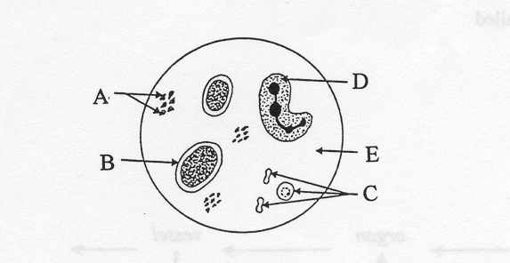

1. In the diagram above of human blood seen through a microscope, which structure is a red blood cell
2. A
3. B
4. C
5. D
6. Which is responsible for engulfing bacteria?
7. A
8. B
9. C
10. D
11. Which component of the blood is important in blood clotting?
12. A
13. B
14. C
15. All of the above
16. The pigment that is present in red blood cells is called
17. Plasma
18. Lymph
19. Haemoglobin
20. Antibodies
21. Red blood cells are produced by
22. Yellow bone marrow
23. Red bone marrow
24. Thymus gland
25. Blood
26. The pressure of blood during the time the ventricles are filling is known as
27. Systolic blood pressure
28. Dialysis blood pressure
29. Diastolic blood pressure
30. Systemic blood pressure
31. Which one of the following statements about the function of blood is not true? Blood
32. Carries hormones from one part of the body to another
33. Transports waste products away from areas of high concentrations
34. Transports nutrients away from areas of high concentrations
35. Provides readily available energy in the form of ATP to the cells
36. A blood vessel (X) supplies blood to muscle tissue while a second blood vessel (Y) removes blood from the muscle tissue. Which of the following statements concerning these blood vessels would be true?
37. blood vessel X has a higher carbon dioxide concentration than vessel Y
38. blood vessel X has a lower concentration of carbon dioxide than vessel Y
39. blood vessel X would contain not contain glucose while blood vessel Y would
40. blood vessel X would have a lower concentration of oxygen than vessel Y.
41. The blood vessels found in a mammalian system that are thin enough to allow diffusion to occur across their walls are called
42. veins
43. capillaries
44. arteries
45. alveoli
46. Carbon dioxide is carried in the blood stream in what form?
47. Dissolved in solution
48. As bicarbonate ions
49. As carbohydrates
50. As carbonic acid

## The data presented below was recorded in an experiment where a subject breathed in and out of a paper bag and the percentage of carbon dioxide in the air in the bag was recorded. The rate and depth of breathing of the subject was also measured.

|  |  |  |
| --- | --- | --- |
|  | Normal breathing | After rebreathing |
| % of CO2 in bag | 0.4 | 1.52 |
| Depth of breathing | 673 mL | 7.94 mL |
| Rate of breathing | 14/min | 15/min |

## Given the data above the volume of air breathed by the subject in one minute of normal breathing is

## 9422L

## 9422mL

## 40L

## 40mL

## What was the percentage change in the depth of breathing between normal breathing and rebreathing?

## 8.4%

## 84.7%

## 1.1%

## 40.6%

## Exchange of gases in the alveolus of the mammalian lung is by

## Osmosis

## Diffusion

## Capillary force

## Dialysis

## **Section B Short Answer 30 Marks**

Question1

Name vessels

1. A______________________________________

B______________________________________

C______________________________________

D______________________________________

(4 marks)

(b) (i) State which vessel(s) carry oxygenated blood using the letter(s) indicated in the diagram above.

____________________________________________________________________________________________________________________________

(2 mark)

**(c)** The diagram below shows the cross section of an artery and a vein respectively.

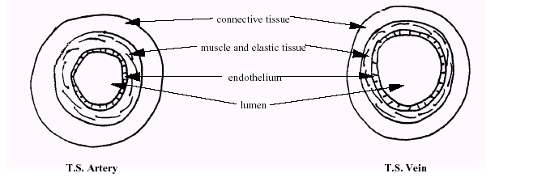(i) What is the role of each of the tissues that makes up the arteries and veins?

(3 marks)

_______________________________________________________________

_______________________________________________________________

_______________________________________________________________

(ii) Why do we describe an artery and a vein as organs? (2 marks)

_______________________________________________________________

_______________________________________________________________

_______________________________________________________________

(iii) What differences in structure are there between an artery and a vein? (3 marks)

_______________________________________________________________

_______________________________________________________________

_____________________________________________________________________________________________________________________________________________________________________________________________

(iv) Why are they structured differently? (2 marks)

_______________________________________________________________

_______________________________________________________________

_______________________________________________________________

_______________________________________________________________

_______________________________________________________________

(v) Consider the effects of a heart attack on the function of the organ above. If the heart attack was the result of damage to the muscular wall of the left ventricle so that the left ventricle was no longer, able to pump the same amount of blood as it did in normal circumstances:

What would be the effect on the individual concerned? Explain your answer.

(2 marks)

_________________________________________________________

_________________________________________________________

_________________________________________________________

Question 2

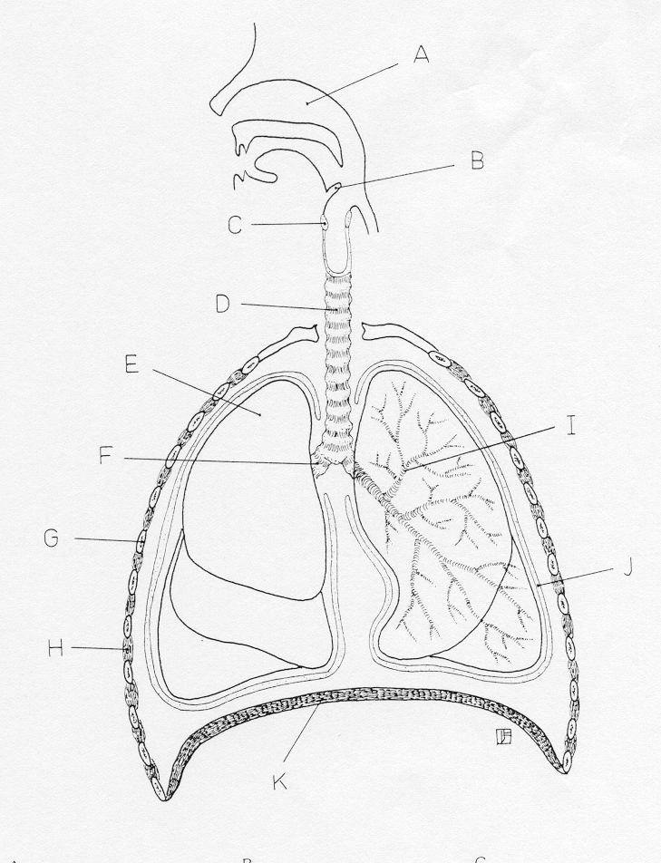

A ______________________ C ___________________

D ______________________ F ___________________

I ______________________ H ___________________

J ______________________ K ___________________

(8 marks)

1. List four features that a respiratory surface has in order to maximise the diffusion of gases.

________________________________________________________________

________________________________________________________________

_________________________________________________________________

_________________________________________________________________

_________________________________________________________________

(4 marks)

**YEAR 11 ATAR HUMAN BIOLOGY**

Test 2:

Circulatory & Respiratory System

SCORES:

MC: /25

SA: /30

TOTAL: /55

_______ %

**NAME:_____________________________**

**TEACHER:__________________________**

**DATE:______________________________**

**Section A: Multiple choice (15 Marks)**

Answer all questions by circling the most correct answer on the multiple choice answer sheet.

1. a b c d 14. a b c d

2. a b c d 15. a b c d

3. a b c d 16. a b c d

4. a b c d 17. a b c d

5. a b c d 18. a b c d

6. a b c d 19. a b c d

7. a b c d 20. a b c d

8. a b c d 21. a b c d

9. a b c d 22. a b c d

10. a b c d 23. a b c d

11. a b c d 24. a b c d

12. a b c d 25. a b c d

13. a b c d

**Question 43 refers to the diagram below.**

43a. Complete the labels from the diagram above.

B_______________________ C ___________________________

E_______________________ F____________________________

#### G_______________________ H____________________________

I________________________ J_____________________________

iii)__________________________________________

(3 marks)